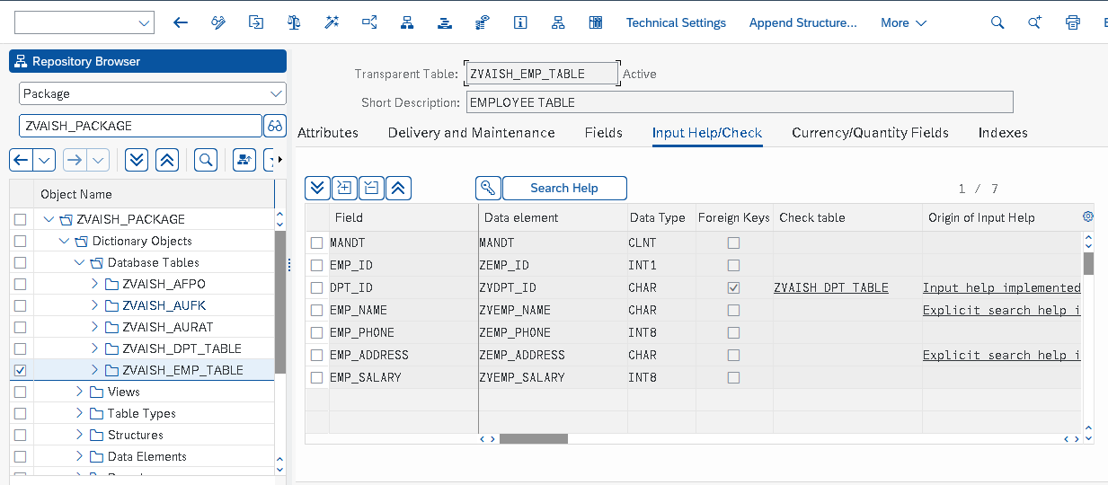1.EMPLOYEE TABLE – ZVAISH_EMP_TABLE

1.a SELECTION SCREEN FOR EMPLOYEE TABLE

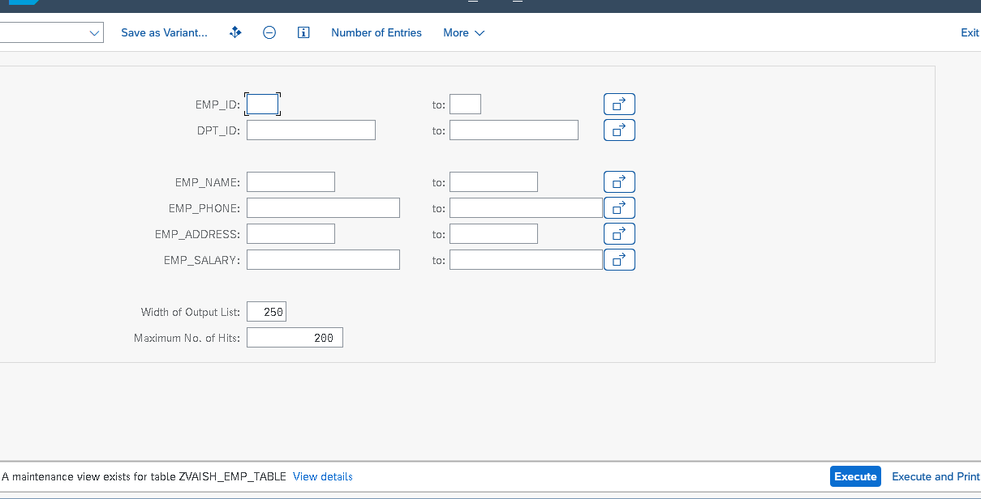

1.b OUTPUT OF THE EMPLOYEE TABLE

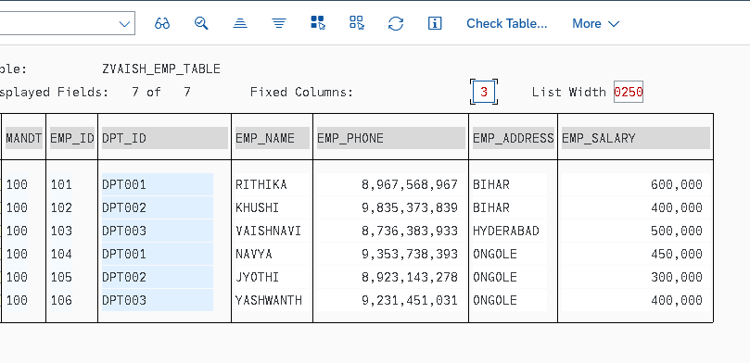

2.Department table

## 

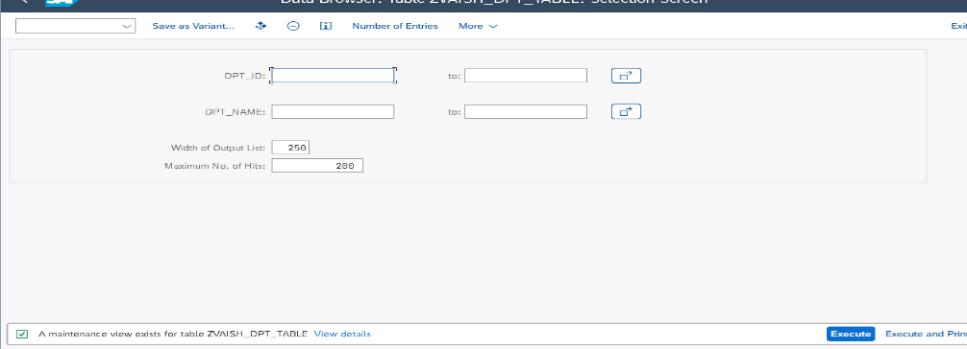2.a Selection screen for department table

2.b Output for department table

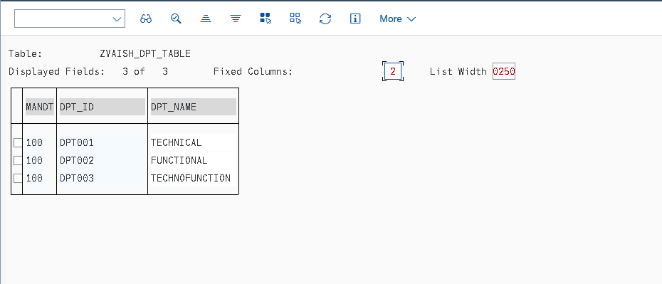

3. VIEW FOR EMPLOYEE TABLE JOIN WITH DEPARMENT TABLE

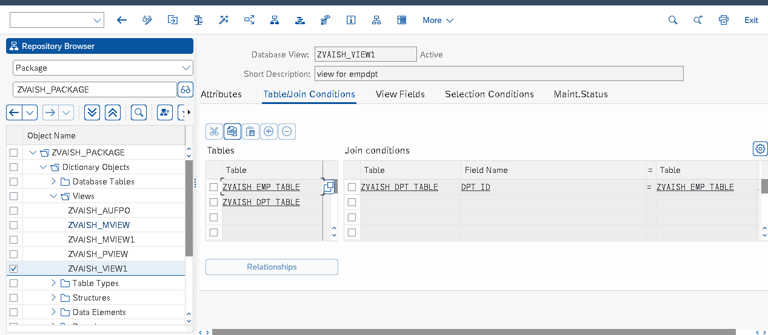

3.a OUTPUT FOR VIEW

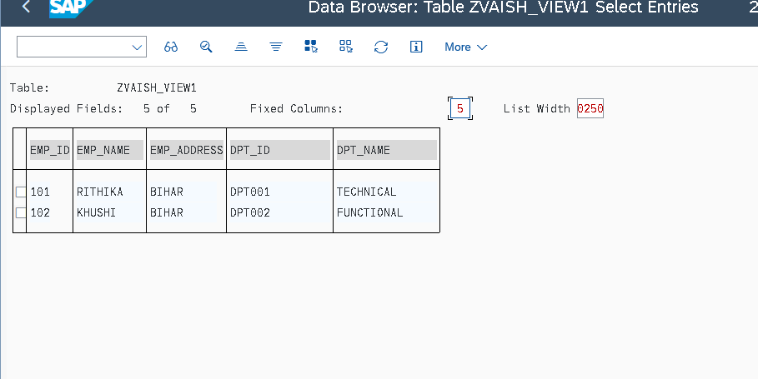

4. PROJECTION VIEW FOR EMPLOYEE TABLE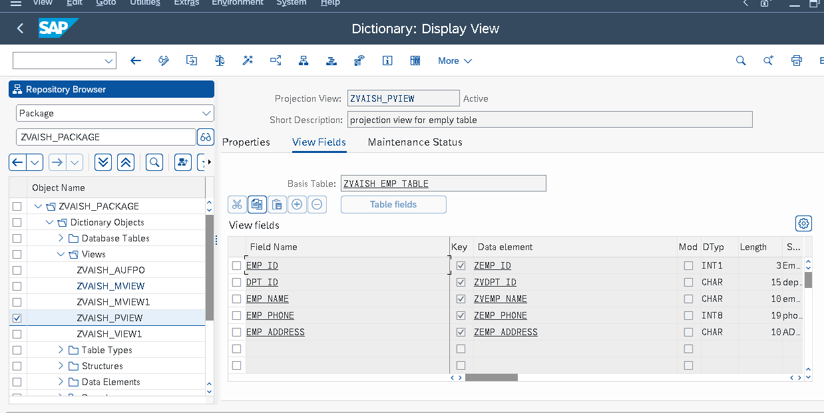

4.a OUPUT FOR PROJECTION VIEW

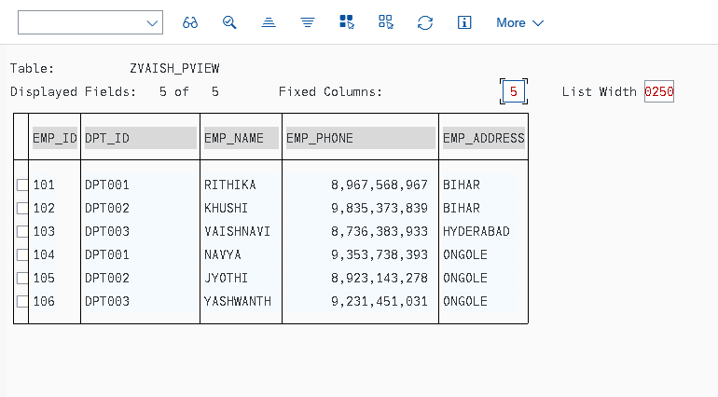5.MAINTANENCE VIEW FOR EMPLOYEE TABLE

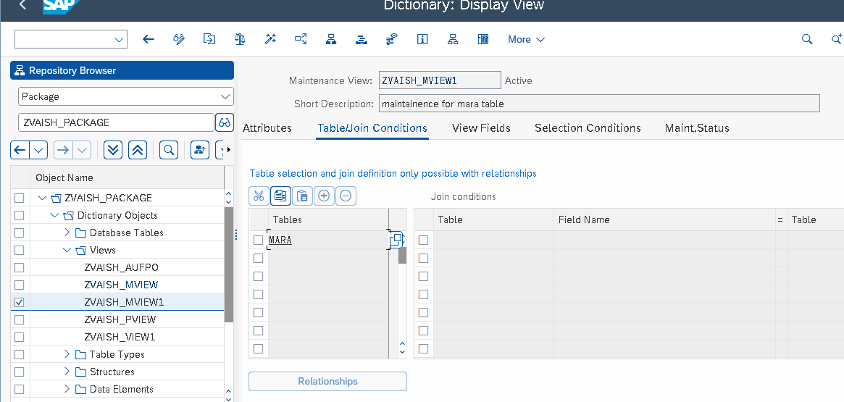

6.STRUCTURE--- TABLE TYPE FOR VBAK TABLE

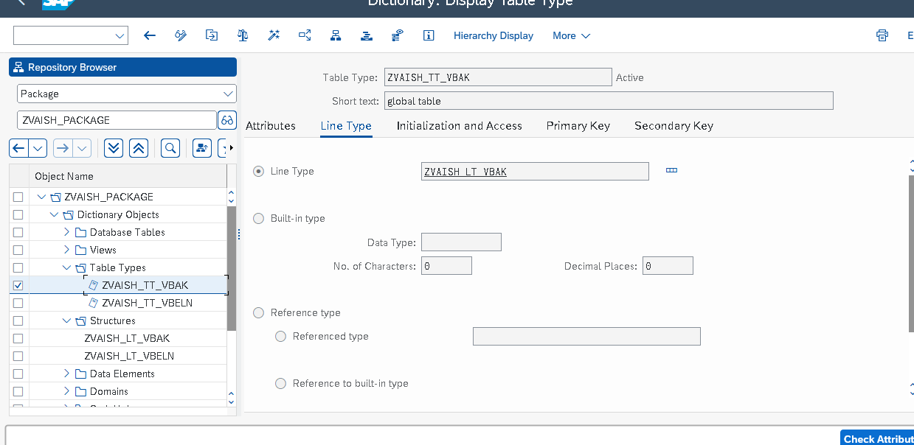

7. STRUCTURE- LINE TYPE FOR VBAK TABLE

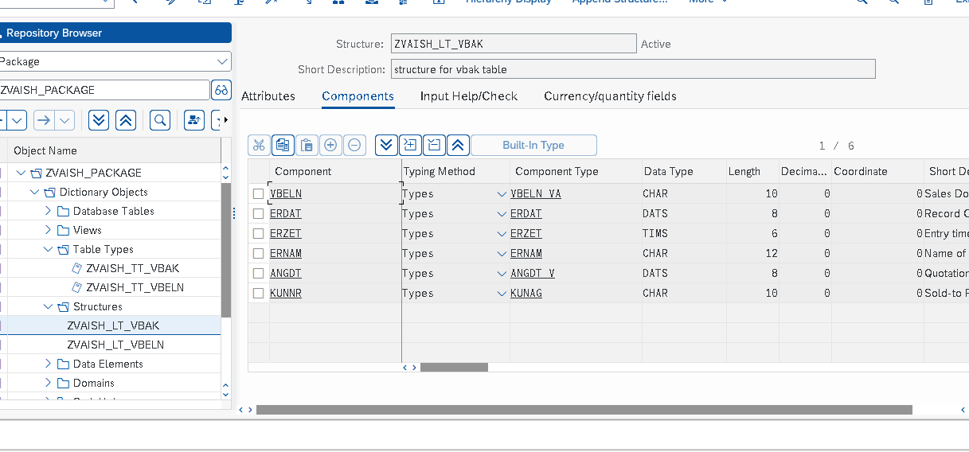

8.SEARCH HELP FOR EMPLOYEE TABLE BY EMP ADDRESS

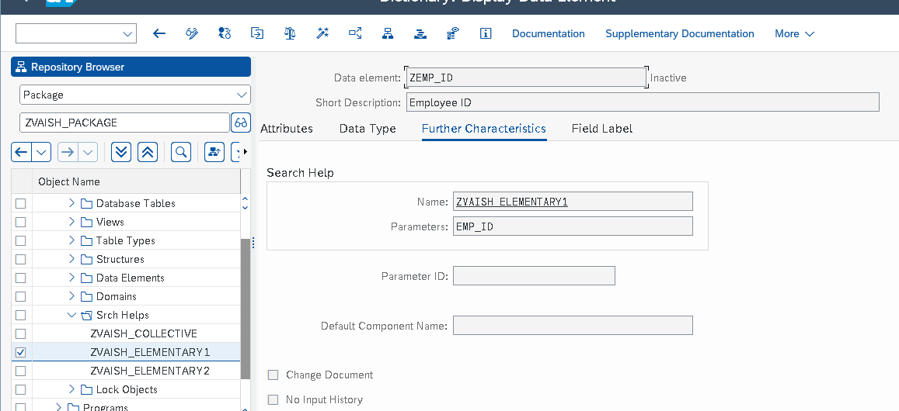

8.a OUTPUT FOR SEARCH HELP 1

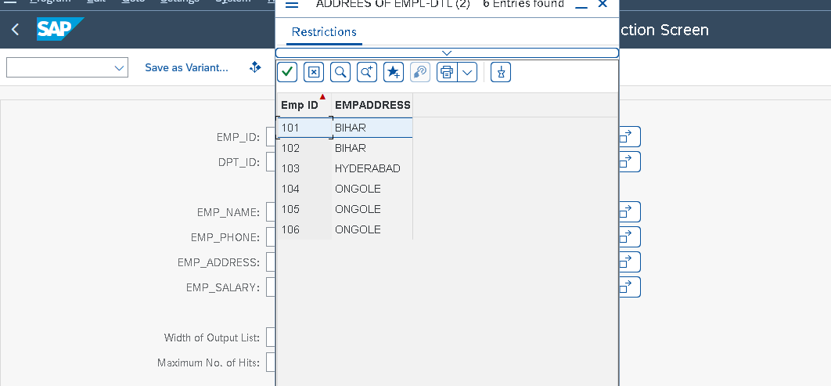

9.SEARCH HELP FOR EMPLOYEE TABLE BY EMP NAME

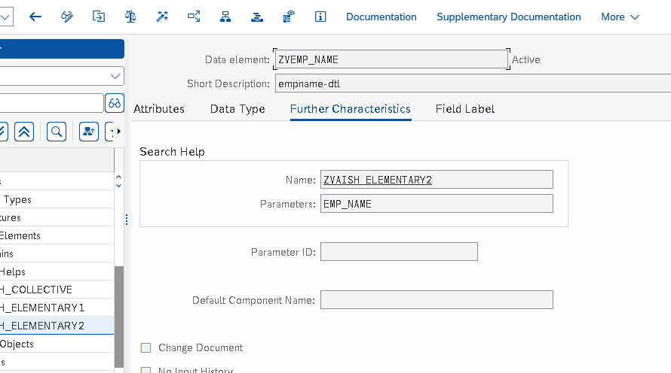

9.a OUTPUT FOR SEARCH HELP2

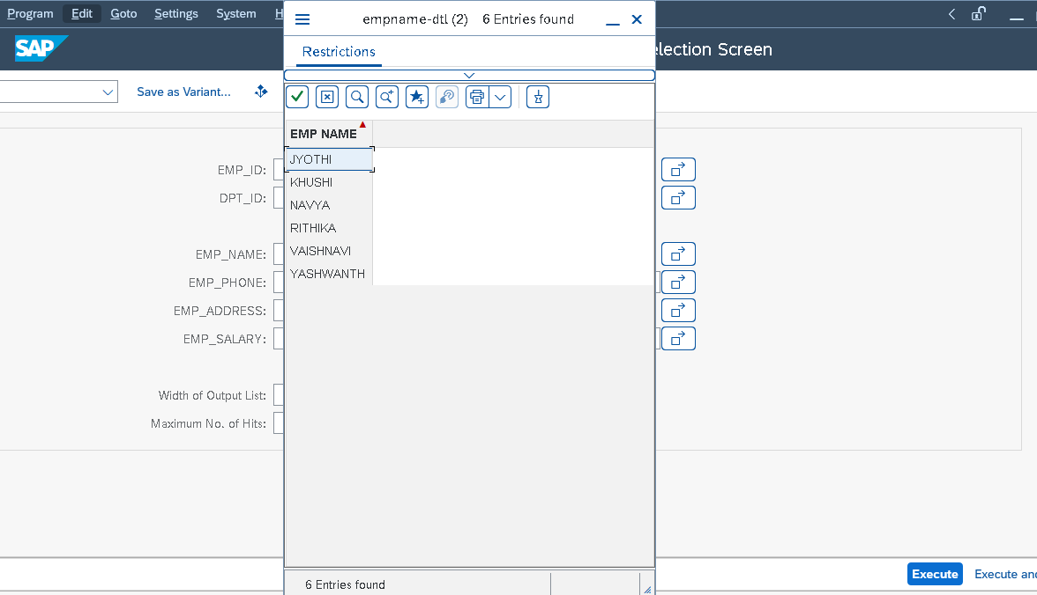

10.COLLECTIVE SEARCH HELP

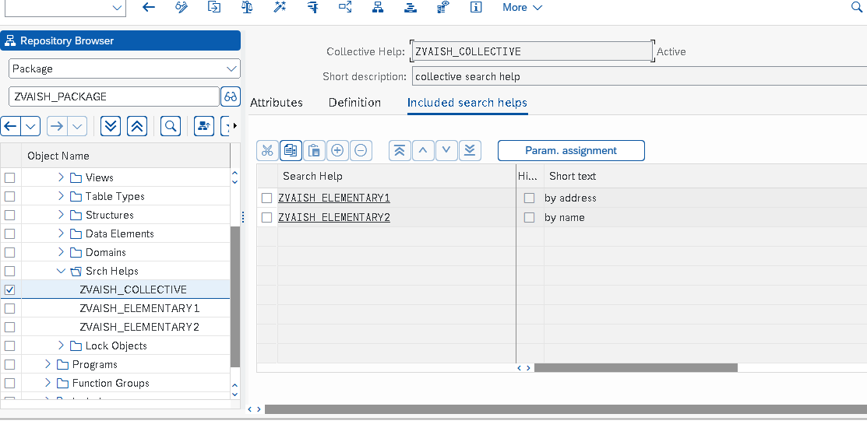

11. FUNCTION GROUP

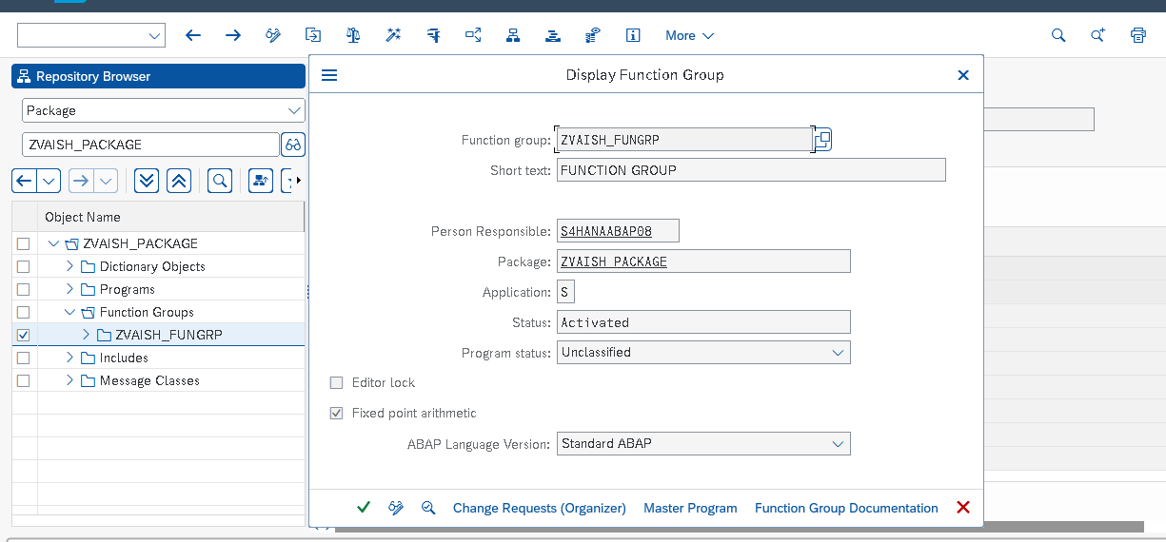

12.INCLUDE FOR VBAK TABLE

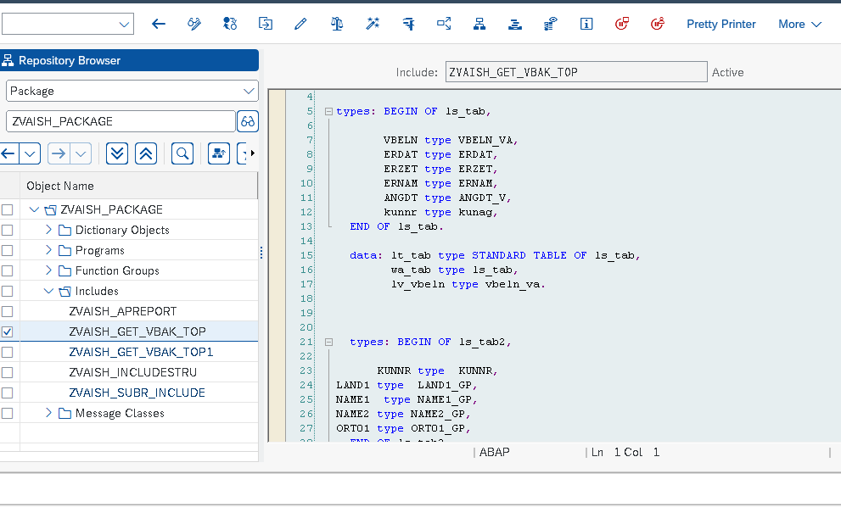

13. SUBROUTINE FOR SUM OF NUMBERS

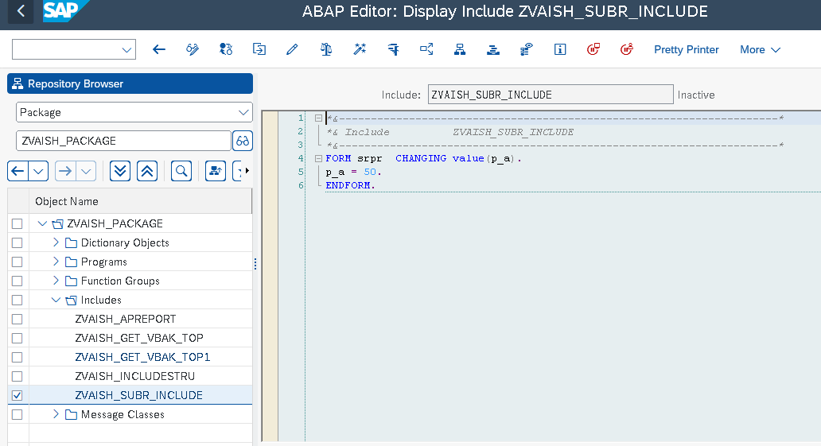

14.DISPLAY MESAAGAES

